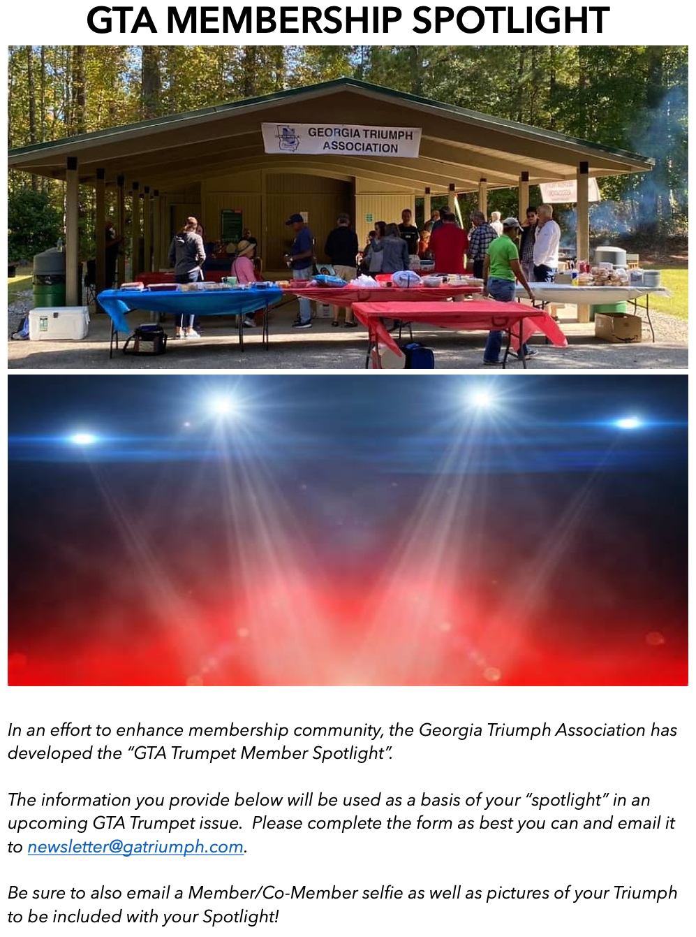GTA Trumpet Member Spotlight Information
Please provide the requested information, as best you can, in the boxes below the headings. The boxes will expand as information is added.
Name of Member:

Name of Co-Member:

Current city of residence:

Hometown(s)--City and State:

Triumph(s) owner since (date):

Current repairs and projects:

Your Triumph Year, Model, Color, Trim:

Transmission:

Options/Modifications:

What do you like best about GTA?

Favorite/funniest Triumph memories:

Biography (background, family, occupation, anything you want to share):

Please don’t forget to take a selfie to be included in our newsletter, as well as a picture of your Triumph(s) and other cars and email the pics along with your completed form to: newsletter@gatriumph.com. So we can edit and finish/doll-up up your Spotlight. Thank you for taking part in our GTA Membership Spotlight!

